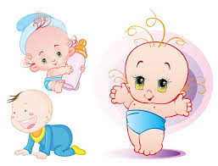

Mina’s Kids Day Care Center
THINGS I NEED

- Formula
- Baby Food
- Baby Cereal
- Snacks
- Blanket/Crib Sheet
- Bibs
- Changing Clothes
- Juice
- Lunch
- Wipes
- Pull Ups
- Diapers

Please bring the above items first day at the day care center.

